TMHCC Fire Protection/Detection Impairment Process

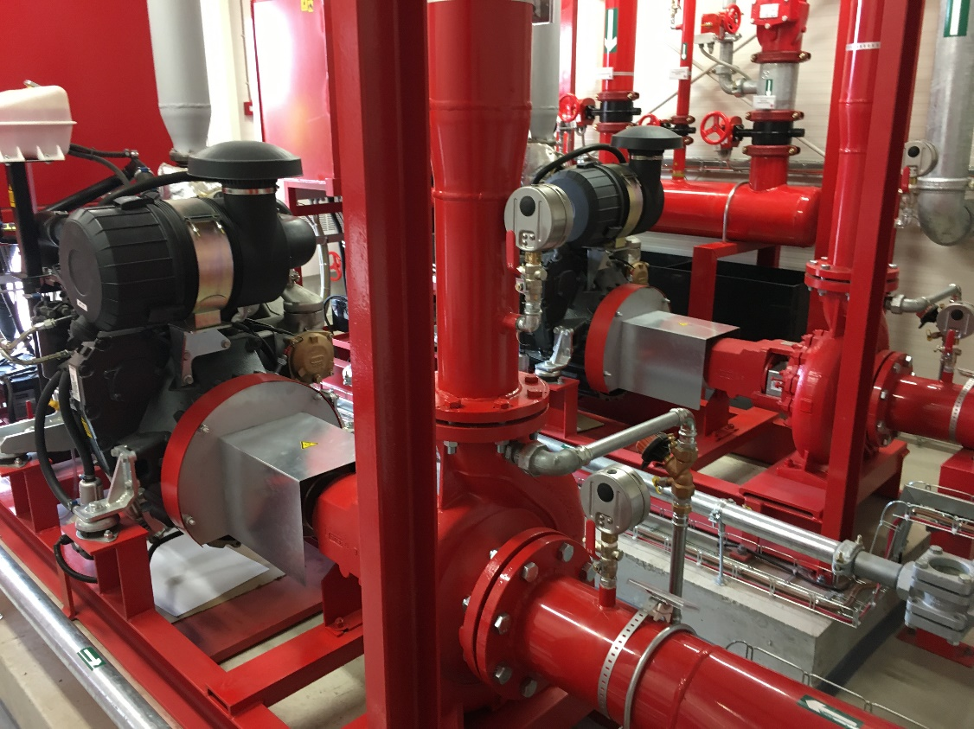

This document contains the following:
- Summary of the process and requirements
- Risk Assessment – CR007a
- Logbook – CR007b (for use under 10 hours)
- Fire Protection/Detection Impairment Form – CR007c (For use over 10 hours)

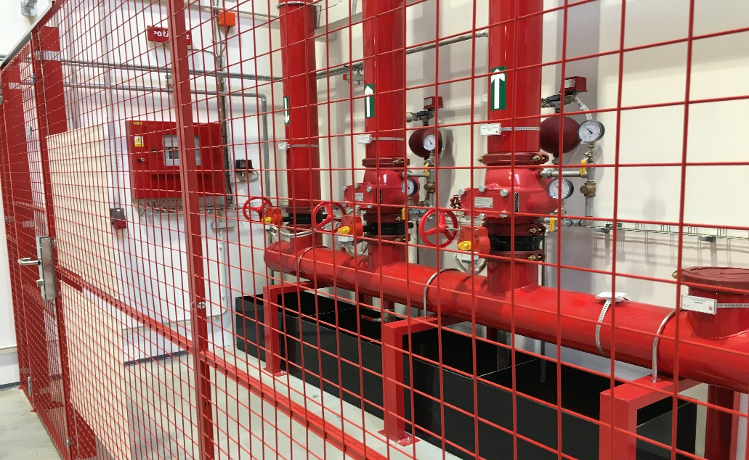

Impairments to Fire Systems

Why does this affect your company?

How does this affect your company?
An impairment is a partial or complete isolation of any type of fire protection or detection system which is installed within your premises. It can also be applicable for security systems.
The essence of this process is to ensure that the impairments are only carried out if absolutely necessary and are monitored to ensure that the system is reactivated at the earliest opportunity. It is essential that all impairments of critical fire systems are kept to the absolute minimum in terms of scope and duration.
The Tokio Marine HCC Impairment System covers all the key elements to consider in order to carry out an impairment safely and quickly. It
is strongly recommended that you contact Tokio Marine HCC if you have any questions about an impairment that you need to implement. Our
risk engineers will be able to provide further advice and guidance based on their experience to help limit the duration and scope of an impairment.
While planned impairments may be necessary during day to day maintenance and projects, it must be understood that if part or all of the fire protection system is impaired then the facility is at risk. The fire protection systems are there because occupancy or process hazards have been identified and the fire risks associated with these need to be minimised. When an impairment occurs, whether it be accidental or planned, it is necessary to minimise the risks. These may include arranging temporary protection, reducing the hazards and managing the impairment to ensure that the impairment is restored in the shortest possible time.
There are three types of impairments that occur:
- the first being a ‘planned impairment’;
- the second being an ‘emergency impairment’;
- and the third and most dangerous is the ‘hidden impairment’.

Obviously, it is preferable to have a planned impairment with time to
prepare. However, when unforeseen circumstances occur it is essential that when a system is isolated due to a problem or fault, that it is not left and forgotten about.

Planned impairments
Planned impairments are implemented during maintenance or projects, or if a fire system needs to be extended/isolated.
Whatever the reason for the impairment, good planning means that the risks can be minimised. In order to minimise the duration of planned impairments all required materials and parts should be on site before isolating the system.

Emergency impairments
Emergency impairments tend to be at a time of routine testing where an impairment has been discovered, or a fire system needs to be shut down in an emergency.

Hidden impairments
Hidden impairments are ones that no one is aware of or that have been forgotten. Correct application of the Tokio Marine HCC Impairment System could help reduce the risk of hidden impairments. Such hidden impairments do occur, and if a system is isolated it will not extinguish a fire or raise the alarm.

What should your company do / have?

Safer alternative
Consider whether the fire system needs to be shut down to complete the job or could another method be implemented to ensure that the systems remain operational.

Tokio Marine HCC impairment system
Apply the Tokio Marine HCC impairment system or an equivalent system and limit the permit validity to one shift only. This should apply to employees as well as contractors, and should form part
of the risk assessment undertaken for the impairment. Hot work, smoking and hazardous operations should not be permitted in the affected area during the impairment.

Notification
Inform department heads, alarm monitoring company, emergency response team members, fire brigade, employees and insurance companies of the impairment. Inform members of the team of any changing situation where the impairment time needs to

What could happen to your company if you don’t take these steps?
It is an interesting statistic that while hot work remains one of the most common causes of fires, most industrial facilities have a Hot Work
Permit system available to use. Clearly simply having a permit system is not protection enough. The system has to be stringently implemented by trained individuals and applied to in-house staff as well as contractors.
be extended and when the system has been restored.

Training
All people involved with impairment activities should be fully trained and educated on implementing impairment handling procedures, together with the possible hazards associated with them.

Manual firefighting equipment
Fire hoses should be laid out and connected, (if not impaired), and/or additional fire extinguishers should be positioned in the area of the impairment. The person undertaking the impairment should be trained in the use of this equipment.

One impairment
As many fire protection/detection systems as possible should remain operational during the period of the impairment. Ensure that the work on the impaired system is expedited and provides a continuous fire watch in the affected area.

Responsible person
There should be dedicated site employees with the authority and knowledge to
issue an impairment system. Contractors should not be allowed to issue any impairment system, and they should be fully supervised on site. Where possible plans should be developed to allow rapid reinstatement of the fire system in the event of an incident.

To obtain copies of the
Tokio Marine HCC Fire Safety Inspections Checklist please contact your local Tokio Marine HCC office or contact:

Risk Engineering Administrator Tokio Marine HCC
1 Aldgate London,
EC3N 1RE
impairments@tmhcc.com

References
- Tokio Marine HCC Impairment System – available in English, French, German and Spanish
- NFPA25 – Inspection and Testing of Water Based Protection Systems

A member of the Tokio Marine HCC group of companies
Tokio Marine HCC is a trading name of HCC International Insurance Company plc, which is a member of the Tokio Marine HCC Group of Companies. HCC International Insurance Company plc is authorised by the Prudential Regulation Authority (PRA) and regulated by the UK Financial Conduct Authority (FCA) and Prudential Regulation Authority. Registered in England and Wales No. 01575839 with registered office at 1 Aldgate, London EC3N 1RE.

tmhcc.com

Fire Protection/Detection Impairment Risk Assessment
(Form – CR007aEN)
Managing your fire protection / detection impairment when fire protection / detection equipment must be taken out of service, this permit system will help you manage your impairment.

Before Impairment
- If possible, plan to do the work when the facility is not operating, and/or shut down hazardous processes.
- Have everything ready before impairing the Fire Protection / Detection systems, i.e. equipment, parts and personnel.
- If sprinklers are to be impaired, plan for temporary protection such as extra extinguishers, charged hose lines, etc.
- Notify the site Emergency Organisation and local Fire Brigade of the planned impairment so that they can be prepared.
- If sprinklers are to be impaired, is someone available to restore the system promptly in the event of fire?
- If the impairment is not going to exceed 10 hours, complete the logbook - form CR007bEN.
- If the impairment is going to exceed the 10 hours, inform Tokio Marine HCC using the form CR007cEN.
During Impairment
- Restrict smoking.
- Restrict hot work including cutting and welding.
- Have guards patrol the area(s) where the Fire Protection / Detection systems are out of service.
- Continue the work until the Fire Protection / Detection systems are restored.
- Where possible aim to reinstate Fire Protection / Detection systems for over night and weekend periods.
After Impairment
- Make certain the Fire Protection / Detection systems are placed back in service as quickly as possible.
- If sprinklers were impaired, conduct a 50mm drain test at the sprinkler riser.
- If sprinklers were impaired, re-lock sprinkler control valve(s) in the wide-open position.
- Re-set the alarm system and notify the Central Station if applicable.
- Notify the site Emergency Organisation and local Fire Brigade that the impairment is over.
- Use the attached form to notify Tokio Marine HCC when the Fire Protection / Detection has been returned to service.
Contact Details
Tokio Marine HCC

Risk Engineering Department

T: +44 (0)203 148 9522
Email: impairments@tmhcc.com

Fire Protection/Detection Impairment Logbook
(Form – CR007bEN)

Company Name …………………………………………………………………………..
Location …………………………………………………………………………….

The TMHCC impairment log sheet system has been created to help manage small, partial or servicing impairments.

This system allows the facility management to supervise their own impairments for up to 10 hours during the normal working day. However, if the impairment is going to exceed the period or is being carried out in a silent or empty building it is essential that the (part c) impairment process is reported to TMHCC, as soon as possible.

System Location or Ref | Time and Date Impaired | All Precautions have been taken | Time and Date Reinstated | All equipment has been checked and is operational | Reason/Comment
e.g. system No 1 | 07.00 30-07-2020 | Yes | 16.00 30-07-2020 | Yes | Servicing

Fire Protection/Detection Impairment Form
(Form – CR007cEN)
Urgent – for attention of Risk Engineering Dept
Parts 1 and 2 of this form should be completed and forwarded to Tokio Marine HCC prior to the fire protection/detection being taken out of service. The form should then be resent with part 3 completed once the protection/detection is back in service. Please email this form to impairments@tmhcc.com. For any queries, please contact Risk Engineering on +44 (0)203 148 9522.
Part 3
After impairment:
Yes/No/NA
 | Is the fire protection/detection back in service?
 | If sprinklers were isolated has a 2in drain test been conducted on the sprinkler riser?
 | If sprinklers were isolated have all the sprinkler control valves been locked back in the open position?
 | Have the alarm systems been reset and the central station notified where applicable?
 | Has the onsite emergency organisation been notified that the impairment is cleared?
 | Has the public fire brigade been notified that the impairment is cleared?
 | Have you notified Tokio Marine HCC that the impairment is cleared?
Actual date isolated? |  |  | Actual time isolated?
Actual date reinstated? |  |  | Actual time reinstated?
Part 1
Insured name:
Insured location
(town and country):
Insured contact name:
Insured contact telephone number:
Insured contact email address:
Insured index number:
Fire protection/detection affected:
Yes/No/NA
Sprinkler
Fire pump
CO2
Other gas protection system
Fire detection system
Other
Areas affected (attach sketch or additional docs if required):
Reason for impairment:
Part 2
Before impairment:
Yes/No/NA
 | Will the facility be operational during the impairment?
 | Will the hazardous processes be shut down during the impairment?
Is everything ready before impairing the fire protection/
detection i.e. equipment, parts and personnel?
 | Has a hydrant been connected to the affected sprinkler riser(s)?
 | Are there additional fire extinguishers in the affected area(s)?
 | Have fire hoses been laid out in the affected area(s)?
 | Are there pipe plugs on site?
 | Has the central station been notified about the impairment?
 | Has the onsite emergency organisation been notified about the impairment?
 | Has the public fire brigade been notified about the impairment?
 | Have you notified Tokio Marine HCC about the impairment?
During impairment:
Yes/No/NA
 | Will hot work be prohibited?
 | Will smoking be restricted?
 | Will continuous work be authorised?
 | Are ongoing patrols of the area planned during the impairment?
 | Will there be someone available to restore the fire protection in the event of a fire?
If possible, are there plans to reinstate the protection/
detection during the night and weekend periods?
Other precautions taken:
Planned date to be isolated? |  | Planned time to be isolated?
Planned date to be reinstated? |  | Planned time to be reinstated?

