Professional Risks

Film & Television Annual Proposal Form

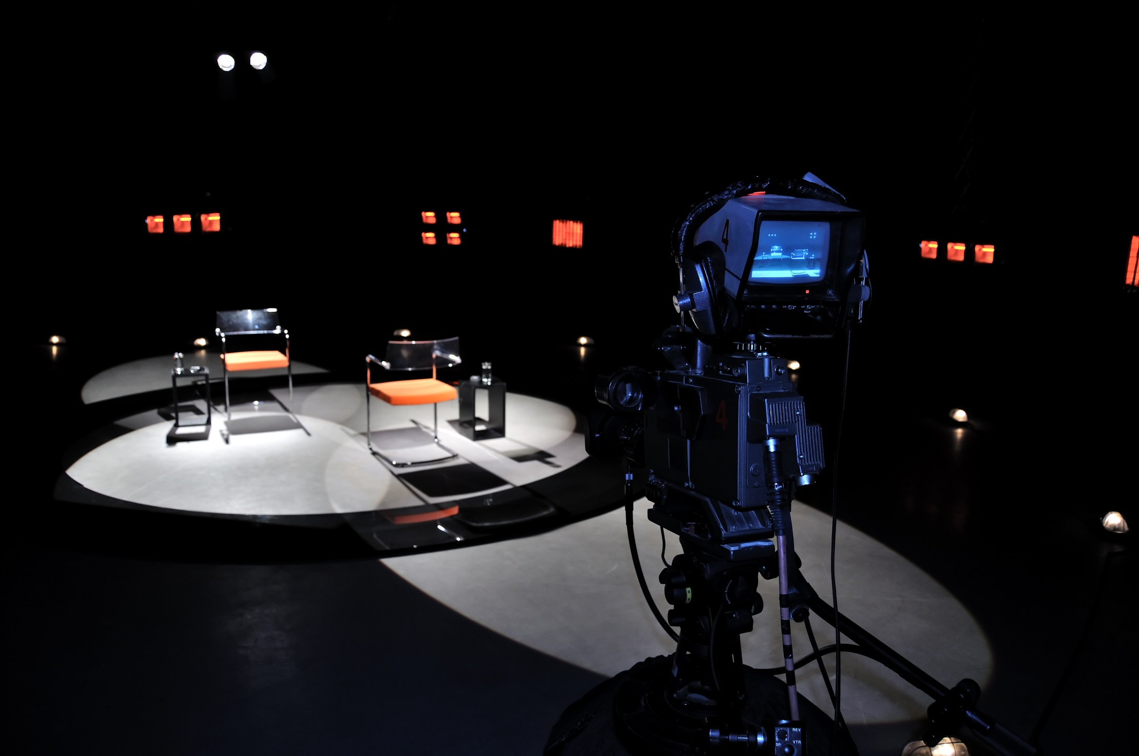

Important Notice

This proposal must be completed and signed by a Principal / Partner / Director of the Proposer/s. The person completing and signing the form should be authorised by the Proposer to do so and should make all reasonable enquiries to enable all the questions to be answered.

All questions must be answered to enable a quotation to be given.

Completing and signing this proposal does not bind the Proposers or Insurers to enter a contract of insurance.

If there is insufficient space to answer questions, please use an additional sheet and attach it to this form (please indicate section number).

# General information

1. Name of proposed insured:

|  |  |
| --- | --- |
| Name: |  |
|  |  |

1. Address:

|  |  |
| --- | --- |
|  |  |
|  |  |
| Website: | Email: |

1. Please supply details of all principals, directors, partners:

|  |  |
| --- | --- |
| Name: | Years in industry? |
|  |  |
|  |  |
|  |  |

1. Additional Insureds to be included for insurance:

|  |  |  |  |  |  |  |  |  |  |  |  |  |  |  |  |  |  |  |
| --- | --- | --- | --- | --- | --- | --- | --- | --- | --- | --- | --- | --- | --- | --- | --- | --- | --- | --- |
|  | | | | | | | | | | | | | | | | | | |
|  | | | | | | | | | | | | | | | | | | |
|  | | | | | | | | | | | | | | | | | | |
| 1. Please give a breakdown of your turnover, including fee income, for the past and current financial years, and estimate for the next year: | | | | | | | | | | | | | |  | | | | |
| Financial year end date  /  / 20 | | | | | | | | | | | | | |  | | | | |
|  | | | | Past year (actual) | | | | | Current year (estimate) | | | | | | | Next year (estimate) | | |
| Total turnover including fee income  GBP / USD / EUR / OTHER | | | |  | | | | |  | | | | | | |  | | |
| 1. Please provide an estimated percentage split of turnover including fee income by geographical territory | | | | | | | | | | | | | | |  | | | |
|  | | | | Past year (actual) | | | | | Current year(estimate) | | | | | | | Next year (estimate) | | |
| United Kingdom clients | | | | % | | | | | % | | | | | | | % | | |
| European clients | | | | % | | | | | % | | | | | | | % | | |
| USA and Canadian clients NOT subject to USA/ Canadian law | | | | % | | | | | % | | | | | | | % | | |
| USA and Canadian clients subject to USA/Canadian law | | | | % | | | | | % | | | | | | | % | | |
| Rest of world clients – please give details of where | | | | % | | | | | % | | | | | | | % | | |
| **TOTAL** | | | | **100%** | | | | | **100%** | | | | | | | **100%** | | |
| 1. Please advise percentage of annual productions produced according to programme type | | | | | | | | | | | | | | |  | | | |
| **Type of production** | | | | **Past financial year** | | | | | **Current financial year** | | | | | | | **Forthcoming financial year** | | |
| Factual (investigative/expose) | | | | % | | | | | % | | | | | | | % | | |
| Factual (non-investigative) | | | | % | | | | | % | | | | | | | % | | |
| Drama | | | | % | | | | | % | | | | | | | % | | |
| Docu-drama | | | | % | | | | | % | | | | | | | % | | |
| Children | | | | % | | | | | % | | | | | | | % | | |
| Religious / Scientific | | | | % | | | | | % | | | | | | | % | | |
| Light entertainment | | | | % | | | | | % | | | | | | | % | | |
| Lifestyle programmes | | | | % | | | | | % | | | | | | | % | | |
| Sports and outside broadcasts | | | | % | | | | | % | | | | | | | % | | |
| Live broadcasts | | | | % | | | | | % | | | | | | | % | | |
| Wildlife / natural history documentaries | | | | % | | | | | % | | | | | | | % | | |
| Reality | | | | % | | | | | % | | | | | | | % | | |
| Animation | | | | % | | | | | % | | | | | | | % | | |
| Other TV (please give details) | | | | % | | | | | % | | | | | | | % | | |
|  | | | | % | | | | | % | | | | | | | % | | |
|  | | | | % | | | | | % | | | | | | | % | | |
| **TOTAL** | | | | **100 %** | | | | | **100 %** | | | | | | | **100 %** | | |
| 1. Please advise: | | | | | | | | | | | | | |  | | | | |
| Average production budget | | Largest production budget | | | | | | | | | | Number of productions per year | | | | | | |
|  | |  | | | | | | | | | |  | | | | | | |
| 1. Territories for distribution: | | | | | | | | | | | | | |  | | | | |
|  | | | | | | | | | | | | | |  | | | | |
| 1. Formats: | | | | | | | | | | | | | |  | | | | |
| 1. Please state additional formats for distribution (eg. DVD / VOD): | | | | | | | | | | | | | |  | | | | |
|  | | | | | | | | | | | | | |  | | | | |
| 1. If necessary, will clearances be obtained for distribution in these formats? | | | | | | | | | | | | | | Yes  No | | | | |
| If **NO**, please give reasons why not: | | | | | | | | | | | | | |  | | | | |
|  | | | | | | | | | | | | | |  | | | | |
|  | | | | | | | | | | | | | |  | | | | |
| 1. Bonus material: | | | | | | | | | | | | | |  | | | | |
| 1. Will any productions be released including bonus material? | | | | | | | | | | | | | | Yes  No | | | | |
| 1. If **YES**, will the bonus material go through the same clearance procedures as the rest of the production? | | | | | | | | | | | | | | Yes  No | | | | |
| If **NO**, please give reasons why not: | | | | | | | | | | | | | |  | | | | |
|  | | | | | | | | | | | | | |  | | | | |
|  | | | | | | | | | | | | | |  | | | | |
|  | | | | | | | | | | | | | |  | | | | |
|  | | | | | | | | | | | | | |  | | | | |
| 1. Please advise the broadcasters to whom you intend to supply programmes: | | | | | | | | | | | | | |  | | | | |
| Broadcasters | | | | | | Type of programme | | | | | | | | | | | | |
|  | | | | | |  | | | | | | | | | | | | |
|  | | | | | |  | | | | | | | | | | | | |
|  | | | | | |  | | | | | | | | | | | | |
|  | | | | | |  | | | | | | | | | | | | |
|  | | | | | |  | | | | | | | | | | | | |
| 1. Do you distribute programmes that you have not produced | | | | | | | | | | | | | | | Yes  No | | | |
| If **YES**, please advise what percentage of your annual turnover related to this activity | | | | | | | | | | | | | | | % | | | |
| 1. Please split this turnover into the following categories | | | | | | | | | | | | | |  | | | | |
| Type of distribution | | | | | | | | % of distribution turnover | | | | | | | | | | |
| 1. Pure distribution where you do not acquire the rights to the productions | | | | | | | | % | | | | | | | | | | |
| 1. Distribution where you have purchased the rights to the production | | | | | | | | % | | | | | | | | | | |
| **TOTAL** | | | | | | | | **100%** | | | | | | | | | | |
| 1. Clearance procedures | | | | | | | |  | | | | | | | | | | |
| Will the script and/or final productions be reviewed by lawyers for libel and related matters? | | | | | | | | | | | | | | | Yes  No | | | |
| Name of clearance lawyer: | | |  | | | | |  | | | | | | | | | | |
| Years’ experience: | | |  | | | | |  | | | | | | | | | | |
| Address: | | |  | | | | |  | | | | | | | | | | |
|  | | |  | | | | |  | | | | | | | | | | |
| If **NO** to 15, please give reasons why not: | | | | |  | | |  | | | | | | | | | | |
|  | | |  | | | | |  | | | | | | | | | | |
|  | | |  | | | | |  | | | | | | | | | | |
|  | | |  | | | | |  | | | | | | | | | | |
| 1. Will all clearances, licences and consents be obtained for all productions in respect of: | | | | | | | | | | | | | | |  | | | |
| 1. Copyright owners | | |  | | | | | | | | | | | | Yes  No | | | |
| 1. Writers | | |  | | | | | | | | | | | | Yes  No | | | |
| 1. Performance/persons appearing | | |  | | | | | | | | | | | | Yes  No | | | |
| 1. Music owners | | |  | | | | | | | | | | | | Yes  No | | | |
| 1. Name or likeness of use | | |  | | | | | | | | | | | | Yes  No | | | |
| 1. Film/ TV clips / photographs of any living or deceased persons | | | | | | | | | | | | | | | Yes  No | | | |
| If **NO** to any of the above, please give reasons why not: | | | | | | | | | | | | | | |  | | | |
|  | | | | | | | | | | | | | | |  | | | |
|  | | | | | | | | | | | | | | |  | | | |
|  | | | | | | | | | | | | | | |  | | | |
| 1. Have all musical rights been obtained in respect of: | | | | | | | | | | | | | | |  | | | |
| 1. Recording synchronisation rights | | | | | | | | | | | | | | | Yes  No | | | |
| 1. Performing rights | | | | | | | | | | | | | | | Yes  No | | | |
| 1. Will all licences and consents granted be checked for any restrictions / qualifications for use? | | | | | | | | | | | | | | | Yes  No | | | |
| If **NO**, please give reasons why not: | | | | | | | | | | | | | | |  | | | |
|  | | | | | | | | | | | | | | |  | | | |
|  | | | | | | | | | | | | | | |  | | | |
|  | | | | | | | | | | | | | | |  | | | |
| 1. Have Title Reports been obtained from a title clearance service and confirmed satisfactory by lawyers? (applicable to US distribution only) | | | | | | | | | | | | | | | Yes  No | | | |
| 1. If productions are not entirely original, please confirm if you are aware of a similar format or idea? | | | | | | | | | | | | | | | Yes  No | | | |
| 1. Please confirm: | | | | | | | | | | | | | | |  | | | |
| 1. The chains of ownership will be investigated and cleared in respect of all marks that are registered for copyright and intended to form the basis of any programme? | | | | | | | | | | | | | | | Yes  No | | | |
| 1. You will check that there are no ambiguities, gaps or problems in respect of the chain of title? | | | | | | | | | | | | | | | Yes  No | | | |
| If **NO** to a or b, please give reasons why not: | | | | | | | | | | | | | | |  | | | |
|  | | | | | | | | | | | | | | |  | | | |
|  | | | | | | | | | | | | | | |  | | | |
|  | | | | | | | | | | | | | | |  | | | |
| 1. Are presenters and guests of live shows briefed in respect of libellous comments prior to broadcast? | | | | | | | | | | | | | | | Yes  No | | | |
| 1. Are lawyers referred to prior to recording, on any contentious issue or matter that could present legal problems as a result of being aired? | | | | | | | | | | | | | | | Yes  No | | | |
| 1. Do you confirm that the clearance procedures attached will be adhered to? | | | | | | | | | | | | | | | Yes  No | | | |
| If **NO** to questions 19 - 21 above, please give reasons why not: | | | | | | | | | | | | | | |  | | | |
|  | | | | | | | | | | | | | | |  | | | |
|  | | | | | | | | | | | | | | |  | | | |
|  | | | | | | | | | | | | | | |  | | | |
| 1. Please advise level or cover required – GBP / USD / EUR / OTHER: | | | | | | | | | | | | | | |  | | | |
| Policy limit |  | each claim / | | | | | | | | in the aggregate | | | | | | | | |
| Excess |  | | | | | |  | | |  | | | | | | | | |
|  | | |  | | | | |  | | | | | | | | | | |
| Claims Declaration | | | | | | | | | | | | |  | | | | | |
| 1. Has any actual or threatened claim been made against you arising out of these productions or any other content relative to these productions? | | | | | | | | | | | | | | | Yes  No | | | |
| If **YES**, please provide details: | | | | | | | | | | | | | | |  | | | |
|  | | | | | | | | | | | | | | | | | | |
|  | | | | | | | | | | | | | | | | | | |
|  | | | | | | | | | | | | | | | | | | |
| 1. During the last five years, has any claim been brought against you arising from defamation, invasion of privacy, infringement of copyright, trademark, unauthorised use of any material, ideas or formats or breach of confidentiality? | | | | | | | | | | | | | | | Yes  No | | | |
| If **YES**, please give details below | | | | | | | | | | | | |  | | | | | |
|  | | | | | | | | | | | | | | | | | | |
|  | | | | | | | | | | | | | | | | | | |
|  | | | | | | | | | | | | | | | | | | |
|  | | | | | | | | | | | | | | | | | | |
|  | | | | | | | | | | | | | | | | | | |
|  | | | | | | | | | | | | | | | | | | |
|  | | | | | | | | | | |  | | | | | |  |

# Please read this paragraph carefully before signing the declaration

It is essential that every Proposal, when seeking a quotation to take out or renew any insurance, discloses to the prospective Insurers all material facts and information (including all material circumstances) which might influence the judgement of an Insurer in deciding whether to accept the risk and on what terms. The obligation to provide this information continues up until the time that there is a completed contract of insurance. Failure to do so entitles the Insurers, if they so wish, to avoid the contract of insurance from inception and so enables them to repudiate liability thereunder. If you have any doubt as to what constitutes a material fact or circumstance please do not hesitate to ask for advice.

# Declaration

On behalf of the Proposer/s, I/we declare that, after full enquiry, the contents of this proposal are true and that I/we have not misstated, omitted or suppressed any material fact or information. If there is any material alteration to the facts and information which I/we have provided or any new material matter arises before the completion of the contract of insurance, I/we undertake to inform the Insurer.

## Signature of Principal / Director / Partner: ­­­­­­­

Date: 

Please use this page for additional information



# CLEARANCE PROCEDURES

### The clearance procedures listed below, which are in no way an exhaustive list of all situations, have been produced as a guide to ensure that the production you are seeking insurance for is subject to all necessary clearances and checks in order to avoid any potential litigation.

### You should consult with your lawyer what the clearance procedures entail and ensure that both you and your lawyer monitor all aspects of the making of the production as well as the clearance of all third party contributions through to the final cut.

1. Any script prior to filming must be reviewed by a lawyer to determine whether there is any defamatory content or potential for a claim to arise.
2. All clearances, licenses and consents must be obtained from all contributing third parties where necessary, for all literary work contained in the production. Any limitations or reservations must be advised to insurers. Where a completed production is being acquired, all rights must still be secured and the origin of the production traced in order to ensure all rights have been obtained. Any excerpts which constitute “fair usage” must be cleared and brought to the attention of insurers.
3. All contributors i.e. creators, authors, writers, owners of any contributing material including quotations, film clips, music, featured copyrighted props must have a written agreement with you which gives authority to you to use their material in the Insured production. You must also have acquired all rights necessary to distribute the production in all forms of media.
4. Releases must also allow you to edit, add and/or delete material and make any changes to the production that you deem appropriate.
5. Any fictional character names, names of businesses, organisations or products should be checked to avoid accidental identification.
6. Any content which is potentially defamatory or legally contentious must be reviewed and cleared by a libel lawyer with any changes adhered to.
7. All rights relative to synchronisation and performance of music must be obtained from copyright owners for use in the Insured production. Any recordings and the use of previously recorded music must also be cleared as new synchronisation and performance licenses may be necessary.
8. All origins of the work should be ascertained. A process should be in place to deal with any unsolicited ideas, formats, material or storylines received from third parties which show similarities to your own production.
9. Any problems relating to clearance or gaps in respect of underlying rights must be advised to Insurers at the outset or at such time when you become aware.

## Data Protection Notice

Tokio Marine HCC respects your right to privacy. In our Privacy Notice (available at https://www.tmhcc.com/en/legal/privacy-policy) we explain who we are, how we collect, share and use personal information about you, and how you can exercise your privacy rights. If you have any questions or concerns about our use of your personal information, then please contact DPO@tmhcc.com.

We may collect your personal information such as name, email address, postal address, telephone number, gender and date of birth. We need the personal information to enter into and perform a contract with you. We retain personal information we collect from you where we have an ongoing legitimate business need to do so.

We may disclose your personal information to:

* our group companies;
* third party services providers and partners who provide data processing services to us or who otherwise process personal information for purposes that are described in our Privacy Notice or notified to you when we collect your personal information;
* any competent law enforcement body, regulatory, government agency, court or other third party where we believe disclosure is necessary (i) as a matter of applicable law or regulation, (ii) to exercise, establish or defend our legal rights, or (iii) to protect your interests or those of any other person;
* a potential buyer (and its agents and advisers) in connection with any proposed purchase, merger or acquisition of any part of our business, provided that we inform the buyer it must use your personal information only for the purposes disclosed in our Privacy Notice; or
* any other person with your consent to the disclosure.

Your personal information may be transferred to, and processed in, countries other than the country in which you are resident. These countries may have data protection laws that are different to the laws of your country. We transfer data within the Tokio Marine group of companies by virtue of our Intra Group Data Transfer Agreement, which includes the EU Standard Contractual Clauses.

We use appropriate technical and organisational measures to protect the personal information that we collect and process about you. The measures we use are designed to provide a level of security appropriate to the risk of processing your personal information.

You are entitled to know what data is held on you and to make what is referred to as a **Data Subject Access Request (‘DSAR’)**. You are also entitled to request that your data be **corrected** in order that we hold accurate records. In certain circumstances, you have other data protection rights such as that of **requesting deletion, objecting to processing, restricting processing** and in some cases **requesting portability**. Further information on your rights is included in our Privacy Notice.

You can **opt-out of marketing communications** we send you at any time. You can exercise this right by clicking on the “unsubscribe” or “opt-out” link in the marketing e-mails we send you. Similarly, if we have collected and processed your personal information with your consent, then you can **withdraw your consent** at any time. Withdrawing your consent will not affect the lawfulness of any processing we conducted prior to your withdrawal, nor will it affect processing of your personal information conducted in reliance on lawful processing grounds other than consent. You have the **right to complain to a data protection authority** about our collection and use of your personal information.

|  |
| --- |
| **Contact Us**  Tel +44 (0)20 7702 4700 mail@tmhcc.com  tmhcc.com  Tokio Marine HCC is a trading name of HCC International Insurance Company plc, which is a member of the Tokio Marine HCC Group of Companies. HCC International Insurance Company plc is authorised by the Prudential Regulation Authority (PRA) and regulated by the UK Financial Conduct Authority (FCA) and Prudential Regulation Authority. Registered in England and Wales No. 01575839 with registered office at 1 Aldgate, London EC3N 1RE | tmhcc.com |